**Installing webIDE**

Download firefox v59 (before installing make sure the previous version of firefox is uninstalled)

<https://ftp.mozilla.org/pub/firefox/releases/59.0/win64/en-US/>

I would also suggest disabling auto updates once Firefox is installed

Menu > options > general

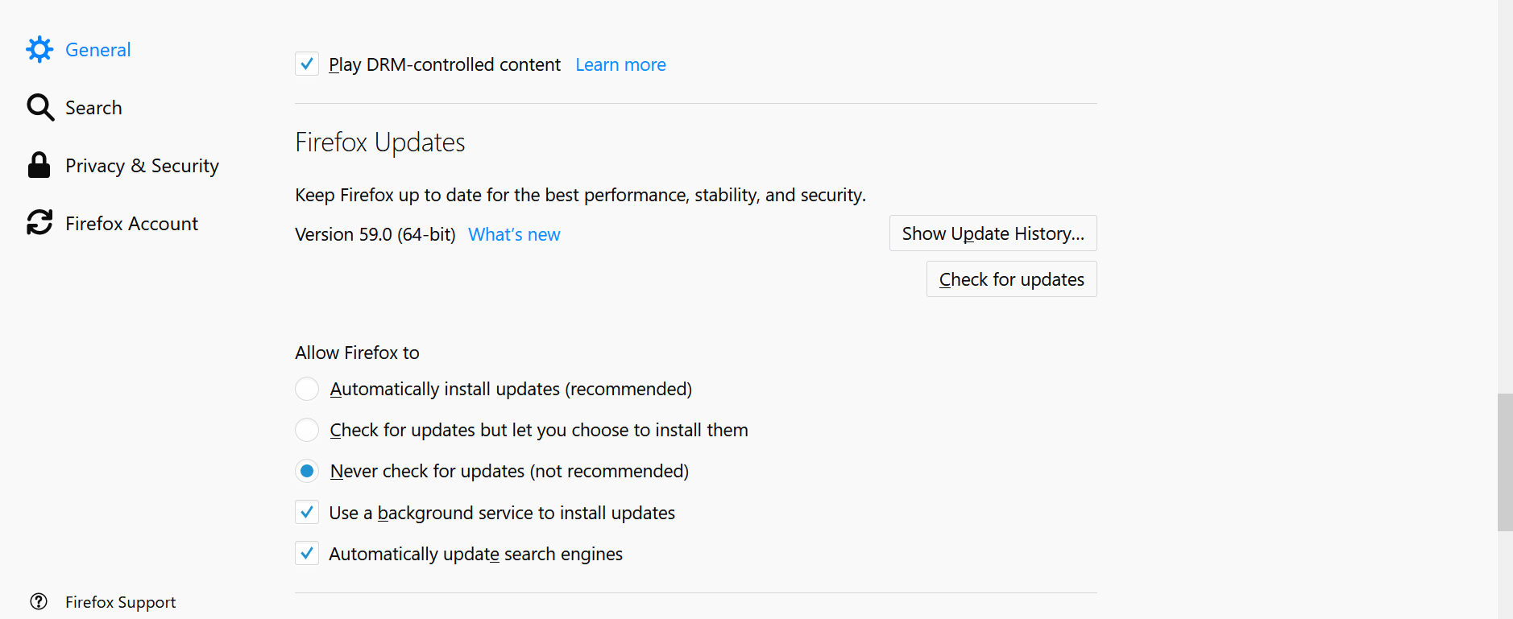

Add this addon

<https://addons.mozilla.org/en-US/firefox/addon/disabled-add-on-fix-57-60/>

Once everything is installed

* in Firefox go to Tools > Web Developer > WebIDE
* on right should see “USB Devices” and should have one device
* on the left have “Open Packaged App” – click it, and choose some app (a folder)
* middle top click the play button… that’s it, app should be on your phone and you should notice it.